PROTECTED B

Amazon Web Services - IRCC Remote Management Strategy

DRAFT
Contents
1 Background 2
2 AWS Management Console 3
3 AWS Remote Management Strategy Overview 4
3.1 AWS Remote Management for Cloud Profiles 5+ connected via GCTIP/GCCAP 5
3.2 AWS Remote Management for Cloud Profiles 3 via Public Internet 7
4 Concept of Operations 9
4.1.1 Governance and Approval 9
4.1.2 Access lifecycle process 9
4.1.3 Access and Control Administration Roles 9
4.1.4 Admin Identity Validation 9
4.1.5 MFA Credentials Management 9
4.1.6 Quality Control and Monitoring of processes 9
4.1.7 Ongoing Monitoring for Abnormal/Malicious Activity 9
4.1.8 Audit Logs Review 9
Addendum - GC Cloud Enablement Cloud Guardrails 10

Table of Figures
Figure 1 - AWS Remote Management Solution via GC-TIP/GC-CAP 6
Figure 3 - AWS Remote Management Solution via Public Internet 8

Revision History
Document Version | Changes | Date | Author
1a | Initial draft | February 28, 2020 | Daniel Cloutier
1b | Added Addendum for GoC Cloud profiles | March 2, 2020 | Daniel Cloutier

Background
As part of the expansion and integration of IRCC’s computing infrastructure into Amazon Web Services Cloud environment, several infrastructure elements must be defined in order to meet immediate and future IT requirements related to cloud computing.
IRCC is going through significant IT infrastructure changes in order to support the overall department growth, the integration of new business lines into IRCC’s systems (such as the Passport program), the migration of legacy datacenters into SSC Enterprise datacenters, the evergreening of the computing environment and other network optimization projects currently underway.
Cloud computing at IRCC is a fairly new concept and involves many different IT areas within the Department.
This document focuses on providing a remote management infrastructure and design for the various IRCC IT administrators responsible for managing the infrastructure, the connectivity and the various cloud applications and services hosted in AWS cloud.
The solutions presented in this document align with the various GoC Cloud profiles documented at the end of this document.

AWS Management Console
The AWS Management Console is a web application for managing Amazon Web Services.
This console provides an inbuilt user interface to perform AWS tasks. These tasks can also be performed using the AWS Client Interface (aka AWS CLI) or the AWS Software Development Kit.
The access to the AWS Management console is performed directly via the Internet (from web proxy services in IRCC’s case).
Authenticating to IRCC AWS accounts with the AWS Management console requires the combination of a username, password and a valid token (generated using Google Authenticator) which provides multifactor authentication.
In order to provide an increased level of security, accessing the AWS Management console should only be performed via the IRCC web proxy server. This access will be monitored and will generate alerts if the AWS administrator is not connecting from the IRCC Proxy server’s public IP address.
Since this document is not meant to provide technical details on how to use the AWS Management Console, the management of AWS cloud services via the latter is provided in separate documents.

AWS Remote Instance/Service Management Strategy
Although multiple management options exists for managing AWS cloud resources such as the AWS Management Console, the remote instance/service management strategy presented in this section relies on the concept of traffic isolation on a per-environment basis which allows for keeping management traffic within a confined area within each AWS account/VPC.
The use of bastion hosts (Linux or Windows) in each account/VPC provide this traffic isolation from other accounts/VPCs as required. Management tools and utilities are installed on these bastion hosts and provide the management end-point for the various instances and systems that are not controlled from the AWS management console.
AWS Network Access Control Lists (NACLs) and AWS Security Groups are put in place to limit access to/from these bastion hosts instances. Access to the bastion hosts is done via SSH or RDP sessions which will be encrypted (using key-pair for SSH and SSL certificate for RDP)
As part of the AWS remote management solution and in order to centralize/control what devices can initiate a session to a bastion host, a cluster of Guacamole servers (https://guacamole.apache.org/) will be installed and provide clientless remote desktop gateway functionality. This gateway will be accessed by remote Cloud/Infrastructure/Application administrators via HTTPS from IRCC on-premise workstations. Since this server provides HTML5 rendering for SSH and RDP protocols, no client software needs to be installed on the workstations.
Authentication to the Guacamole server will be configured with MFA. The Multi-Factor authentication is provided by the built-in TOTP plugin and will works with Google Authenticator which is also used for AWS Management Console access.
In order to centralize AWS Remote Management services, an account named RemoteAccess has been created under IRCC’s AWS PBMM environment. Since the solution will provide remote management services for various cloud usage profiles, two dedicated remote access VPCs will be provisioned and connected to their corresponding Transit Gateways which have been configured to provide traffic separation under IRCC’s AWS cloud space.
It’s also important to note that direct management of cloud instances and services (e.g. SQL Management tools) from an IRCC workstation will not be allowed with this solution.

AWS Remote Management for Cloud Profiles 5+ connected via GCTIP/GCCAP
In this scenario the remote management solution leverages the GC-TIP Cloud/Ground connectivity.
The simplified diagram on the next page depicts the remote access scenario presented in this section, leveraging the GC-TIP connectivity in order to initiate remote management sessions from IRCC’s on-premise network:
- The Transit Gateway used in this scenario is attached to the GC-TIP and GC-CAP VPCs. This Transit Gateway only routes traffic to/from Cloud Profile 5+ environments VPCs which can make use of the GC-TIP/GC-CAP SSC infrastructures.
- A dedicated Guacamole server cluster front-ended with a network load-balancer is deployed under the RemoteAccess AWS Account under a VPC called SCED Remote Access.
- Guacamole servers are configured with MFA using Google Authenticator.
- A private SSL certificate (e.g. .access.rm.aws.ci.gc.ca ; where “rm” stands for “Remote Management”) is installed on the Guacamole servers in order to provide TLS encryption between the IRCC workstations and the Guacamole servers.
- The Guacamole servers connect to bastions hosts located in applications accounts via RDP (configured with TLS, using internal certificates) and SSH (using key-pairs)
- Management Tools are installed on the bastion hosts. The management flows are initiated from this bastion hosts to the services/instances located in the same account as the bastion hosts.
- AWS Security Groups and Network ACLs are configured to only allow approved/required traffic to/from instances, services and subnets (where applicable)
- GC-CAP/Internet flows are permitted between the Internal Remote Access instances and the IRCC GC-CAP firewalls in order to allow for software updates/download required by this hosted solution.

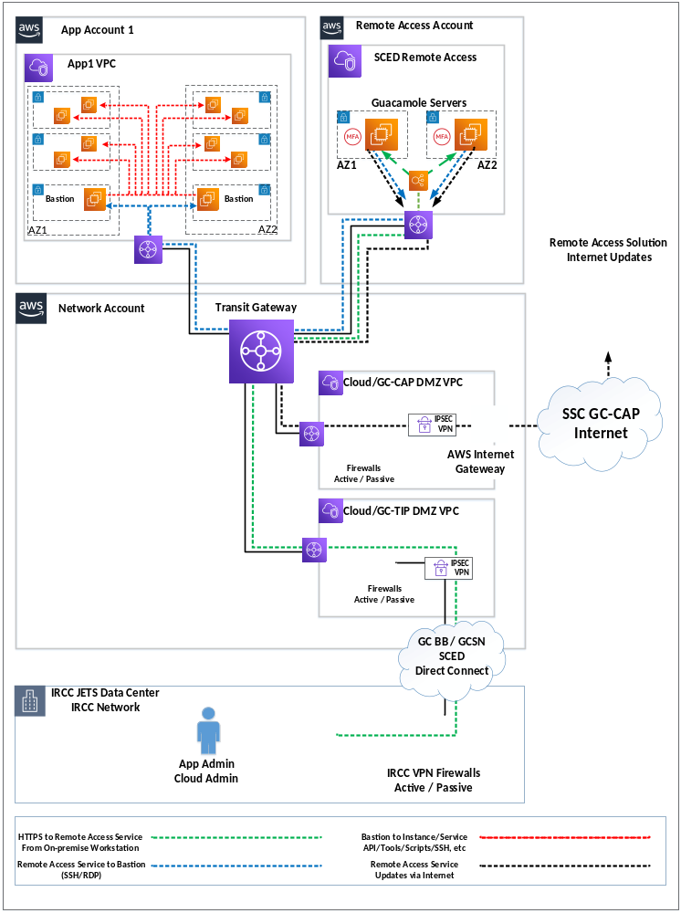
Figure 1 - AWS Remote Management Solution via GC-TIP/GC-CAP

AWS Remote Management for Cloud Profiles 3 via Public Internet

General Characteristics
In this scenario the remote management solution is made accessible from the Internet via IRCC’s proxy server environment.
The simplified diagram on the next page depicts the remote access scenario presented in this section, leveraging a cluster of IRCC managed Fortigate Firewalls providing Internet connectivity for Cloud Profile 3 applications.
- This solution is secured and controlled by IRCC managed Fortigate firewalls hosted under AWS.
- The Transit Gateway used in this scenario is attached to the Managed Internet Access VPC. This Transit Gateway only routes traffic to/from Cloud Profile 3 environments VPCs which do not make use of the GC-TIP/GC-CAP SSC infrastructures.
- A dedicated Guacamole server cluster front-ended with a network load-balancer is deployed under the RemoteAccess AWS Account under a VPC called Public Remote Access.
- Guacamole servers are configured with MFA using Google Authenticator.
- A public SSL certificate (e.g. access.rm.apps.cic.gc.ca; where “rm” stands for “Remote Management”) is installed on the Guacamole servers in order to provide TLS encryption between the IRCC workstations and the Guacamole servers.
- The Guacamole servers connect to bastions hosts located in applications accounts via RDP (configured with TLS using private certificates) and SSH (using key-pairs)
- Management Tools are installed on the bastion hosts. The management flows are initiated from this bastion hosts to the services/instances located in the same account as the bastion hosts.
- AWS Security Groups and Network ACLs are configured to only allow approved/required traffic to/from instances, services and subnets (where applicable)
- Internet flows are permitted between the External Remote Access instances and the firewalls located in the Managed Internet Access VPC in order to allow for software updates/download required by this hosted solution.
- Firewall policies are put in place to only allow for HTTPS Remote Management traffic initiated from within IRCC’s Proxy servers.

Diagram
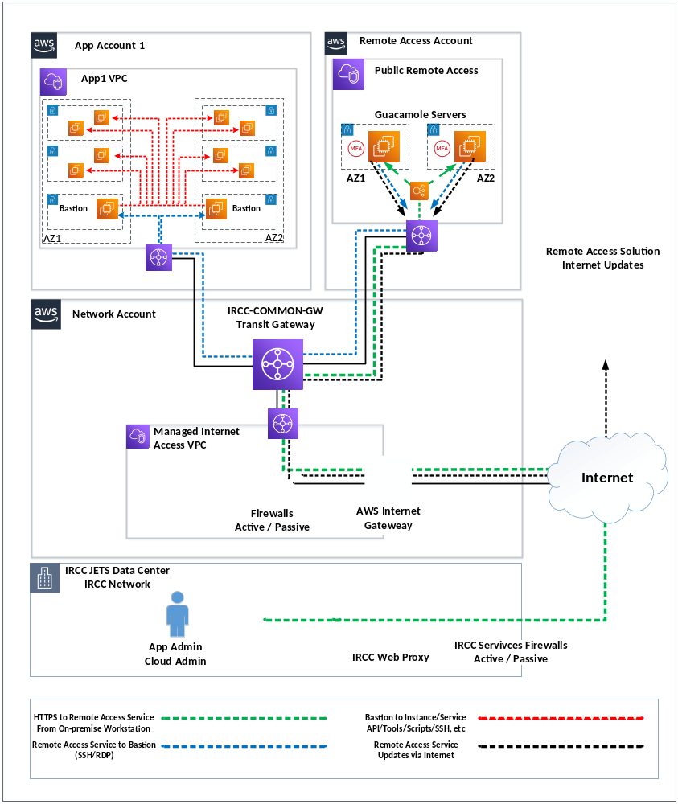
Figure 3 - AWS Remote Management Solution via Public Internet

Concept of Operations

Governance and Approval
Who decides who can access your servers or privileged accounts?

Access lifecycle process
What process do you follow to give someone access? To monitor or remove that access?

Access and Control Administration Roles
Who manages the user accounts used to access privileged accounts and systems?

Admin Identity Validation
What process do you follow to validate their identity?

MFA Credentials Management
What process do you use to handle lost MFA credentials or forgotten passwords?

Quality Control and Monitoring of processes
Who monitors the effectiveness of your processes/controls?

Ongoing Monitoring for Abnormal/Malicious Activity
What process do you follow when you detect abnormal/malicious activity?

Audit Logs Review
Who reviews the audit logs or watches the recorded sessions to detect potential threats?
Do you have disparate processes for different privileged systems (for example, Windows versus UNIX/Linux or data center versus cloud)?

Addendum - GC Cloud Enablement Cloud Guardrails
The following section describes the various cloud profiles as defined by GoC. The cloud usage profiles support the operationalization framework for enabling secure access to Protected B Cloud Services.

Ref. |  | SSC GC Cloud Enablement Cloud Guardrails Addendum
Title | Characteristics |  | Applicable Cloud Service Models
1 | Experimentation/Sandbox | - No system to system interconnections required back to GC data centers | IaaS, PaaS, SaaS
2 | Non-sensitive cloud-based services | - Cloud-based services hosting non-sensitive GC content  - No system to system interconnections required back to GC data centers | IaaS, PaaS, SaaS
3 | Sensitive (up to PB) cloud-based services | - Cloud-based services hosting sensitive (up to Protected B) information  - No system to system interconnections required with GC data centers  - Users access cloud services over secure protocol (e.g. TLS)  - Connections to publicly accessible API services (that are exposing data from systems hosted in GC data centers). | IaaS, PaaS, SaaS
4 | Sensitive (up to PB) cloud-based services for GC-wide SaaS Solutions | - Cloud-based services hosting sensitive (up to Protected B) information for GC-wide enterprise applications (SaaS)  - No system to system interconnections required with GC data centers  - Connections to publicly accessible API services (that are exposing data from systems hosted in GC data centers). | SaaS
5 | GC to GC only (Hybrid IT -Extension of GC Data Centers) | - Hybrid IT environment with an extension of GC network to cloud-based virtual private cloud (up to Protected B) information  - Protection measures to protect from external access to the private departmental virtual cloud instance deployed in the departmental cloud tenant (e.g. extension of GC data centers)  - Restricted environment for GC users only  - No external connections to cloud-based virtual private cloud, no publicly accessible services  - Cloud-based system to system interconnections required with GC data centers | IaaS, PaaS
6 | Cloud-based services with External user access and interconnection to GC data centers | - Cloud-based services hosting sensitive (up to Protected B) information  - Cloud-based system to system interconnections required with GC data center  - Environment accessible for both GC users and External users and services  - Solution implemented, managed and operated by a GC department/agency  - Protection measures from untrusted/Internet traffic to cloud-based service (e.g. GC Cloud Access Point) | IaaS, PaaS
7 | Cloud-based services provided by a Managed Service Provider | - Cloud-based services hosting GC information (Unclassified up to Protected B)  - Cloud-based system to system interconnections required with GC data centers  - Environment accessible for both GC users and External users and services  - Solution implemented, managed and operated by a Managed Service Provider  - Protection measures from required for:  - untrusted/Internet traffic to cloud-based service (e.g. GC Cloud Access Point)  - cloud-based service to GC Data Centers where the service/solution is not fully managed by the GC (e.g. GC Trusted Interconnection Points) | IaaS, PaaS

